

Progressive Education Society's

**Modern College of Engineering, Pune-05.**

1186A, Shivaji Nagar, Pune- 411 005.

**PROJECT LOG BOOK**

**Year: 2021 - 2022**

|  |  |
| --- | --- |
| Project Group ID: | A6 |
| Project Title: | Stock Candle |
| Project Domain: | Time Series Forecasting |
| Internal Guide: | Prof. Yogita Fatangare |

**VISION AND MISSION OF THE INSTITUTE**

**Vision Statement:**

To create a collaborative academic environment to foster professional excellence and ethical values

**Mission Statement:**

To develop outstanding professionals with high ethical standards capable of creating and

managing global enterprises.

To foster innovation and research by providing a stimulating learning environment.

To ensure equitable development of students of all ability levels and backgrounds

To be responsive to changes in technology, socio-economic and environmental conditions.

To foster and maintain mutually beneficial partnerships with alumni and industry.

**VISION AND MISSION OF THE DEPARTMENT**

**Vision Statement:**

To develop proficient IT engineers for the benefit of Industry and Society.

**Mission Statement:**

To achieve academic excellence.

To develop students for being competent in dynamic IT environment.

To encourage research and innovation.

To inculcate moral and professional ethics.

**INDEX**

|  |  |  |
| --- | --- | --- |
| **Sr. No** | **Particulars** | **Page No.** |
|  | Guidelines | 3 |
|  | Undertaking by the students | 4 |
|  | Student Details | 5 |
|  | Sponsorship Details | 6 |
|  | Planner of the project work | 7,8 |
|  | Abstract as per report | 9 |
|  | Work Details | 10 |
|  | Project Poster Details | 11 |
|  | Project Tool Details | 12 |
|  | Project Test Case Execution Details | 13 |
|  | Weekly Planning Sheet for Semester-II | 14 |
|  | Project Review-III | 15,16 |
|  | Project Review-IV | 17,18 |
|  | Partial/Final Report Contents | 19,20 |
|  | Project Report Format | 21,24 |
|  | Communication details with Mentors (if applicable) | 25 |
|  | Observations by External Examiners | 25 |
|  | Co-Curricular Activity Record | 26 |
|  | Sponsorship Letter | 27 |
|  | Internship Letter | 28 |
|  | Published Paper | 29 |
|  | Project Related Certificates | 30 |

**GUIDELINES**

1. Handle the log book carefully.
2. Student must enter the correct information in the log book.
3. All the entries in the log book should be verified by the concerned guide.
4. Student must report to their respective guide as per the schedule.
5. Activity planned should be completed as per the schedule.
6. Submit soft & hard copies of Synopsis, SRS, and Phase – I, Final reports and working project soft copy as per University guidelines.
7. This book, along with final report must be submitted to Guide before final submission / exam of project.

**UNDERTAKING BY STUDENTS**

We, the students of B.E. I.T. are hereby assure that we will follow all the rules and regulations of SPPU related to the project work for the academic year 20 - 20 . The Project entitled

Stock Candle

will be fully designed and developed by us and no part of the project/full project will be designed and developed by any external entity or copied from some external resources. We are fully aware that copying or taking help of any external agency in the development of our project is totally unethical and illegal. The examiners have /University has full rights to initiate an action against us as per University norms if involved in unfair/illegal/unethical work.

|  |  |  |  |
| --- | --- | --- | --- |
| **Sr. No.** | **Roll No** | **Name of Student** | **Signature** |
| 1 | 45001 | Utkarsha Abhang |  |
| 2 | 45002 | Piyush Adhalikar |  |
| 3 | 45051 | Atharva Mulay |  |
| 4 | 45050 | Anushka Mulay |  |

**STUDENT DETAILS**

|  |  |
| --- | --- |
| **Year: 2021-22** |  |
| **Project Group No. : A6** | *A1-College Code (e.g.A1-31)* |
| **Project Title: Stock Candle** |  |

**Group Details:**

|  |  |  |  |  |  |
| --- | --- | --- | --- | --- | --- |
| **Sr No** | **Roll No** | **Name of Student** | **Mobile No.** | **Email-Id** | **TE Result** |
| 1 | 45001 | Utkarsha Abhang | 7744893582 | Utkarsha.manik@moderncoe.edu.in | 9.7 |
| 2 | 45002 | Piyush Adhalikar | 9730046037 | piyush.adhalikar@moderncoe.edu.in | 9.89 |
| 3 | 45051 | Atharva Mulay | 8275272640 | atharva.mulay@moderncoe.edu.in | 9.93 |
| 4 | 45050 | Anushka Mulay | 8275273140 | anushka.mulay@moderncoe.edu.in | 9.98 |

Prof. Yogita Fatangare Prof. S. D. Deshpande

|  |  |  |
| --- | --- | --- |
| Name & Signature of Internal Guide | Name & Signature of External Guide | Signature of Head of Department |
| Mobile No: 9923679494 | Mobile No: |  |
| Email ID: | Email ID: |  |
|  | Company Name: |  |

**SPONSORSHIP DETAILS**

Name of Sponsored Company:



Address:





Tel. No: Mobile No:



Website:_______________________________________________

Person to Contact / Guide / Mentor: 1._____________________________________________________________________________________________

Mobile No.:_____________________Email ID: ____________________________________________

2._______________________________________________________________________________________________

Mobile No.:_____________________Email ID: ____________________________________________

**PROJECT PLANNER OF THE PROJECT WORK**

(To be prepared by the student)

**Project Planner 2.0**

**Semester II**

|  |  |  |
| --- | --- | --- |
| **Sr. No.** | **Activity Schedule** | **Date** |
|  |  |  |
| 1 | Project planning and requirement gathering | 20/12/2021 |
| 2 | Learning Streamlit and flask Framework | 11/01/2022 |
| 3 | Study of fb’s prophet algorithm | 24/01/2022 |
| 4 | Updating UML diagrams | 27/01/2022 |
| 5 | Preparing project report | 31/01/2022 |
| 6 | Designing front end –login/registration | 09/02/2022 |
| 7 | Creating firebase database | 25/02/2022 |
| 8 | Authenticating firebase DB | 01/03/2022 |
| 9 | connecting DB to forms | 08/03/2022 |
| 10 | Extracting and Adding ticker symbols | 14/03/2022 |
| 11 | Creating prediction model | 03/04/2022 |
| 12 | Connecting model to front end | 15/04/2022 |
|  |  |  |
|  |  |  |
|  |  |  |

**ABSTRACT AS PER REPORT**

In the era of big data, deep learning for predicting stock market prices and trends has become even more popular than before. We will be collecting 6 months of data from API and will propose a comprehensive customization of feature engineering and deep learning-based model for predicting price trend of stock markets. The proposed solution will include pre-processing of the stock market dataset, utilization of multiple feature engineering techniques, combined with a customized deep learning based system for stock market price trend prediction.

Finance is highly nonlinear and sometimes stock price data can even seem completely random. Traditional time series methods such as ARIMA ,SARIMA and GARCH models are effective only when the series is stationary. This is combated by using **Facebook’s Prophet** which do not require any stationarity to be used.

We have used prophet for predicting the identified stock future prices. This model is trained by giving past 7 years of data of a particular company stock, Then it is possible to do prediction of next 4 years of stock price. To enhance performance of model, different optimization techniques can be used. Optimization through RMS prop is best optimization in predicting stock price.

**WORK DETAILS**

Use Case

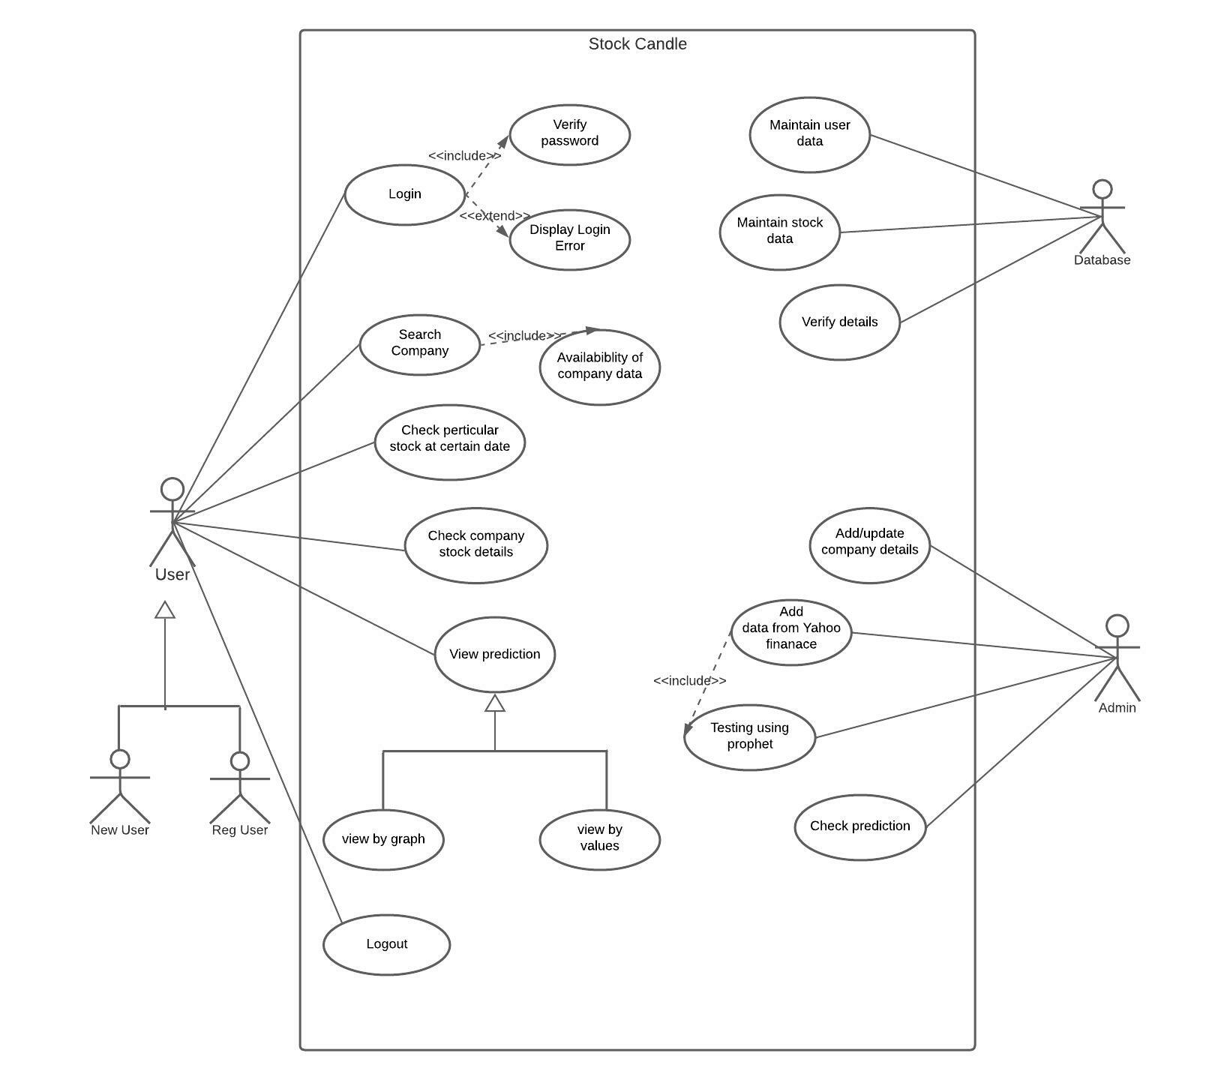

Activity Diagram

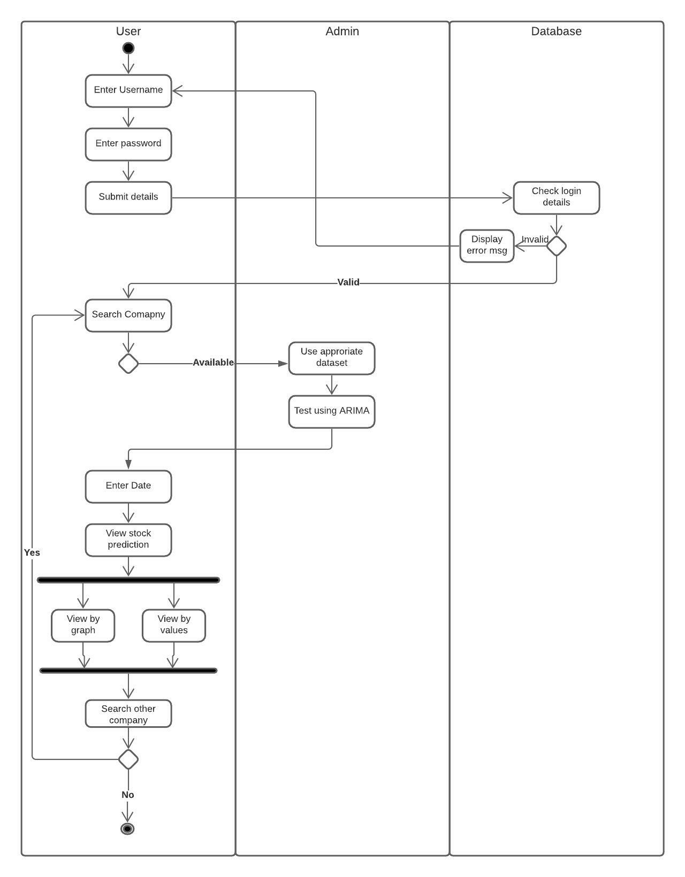

Sequence Diagrams

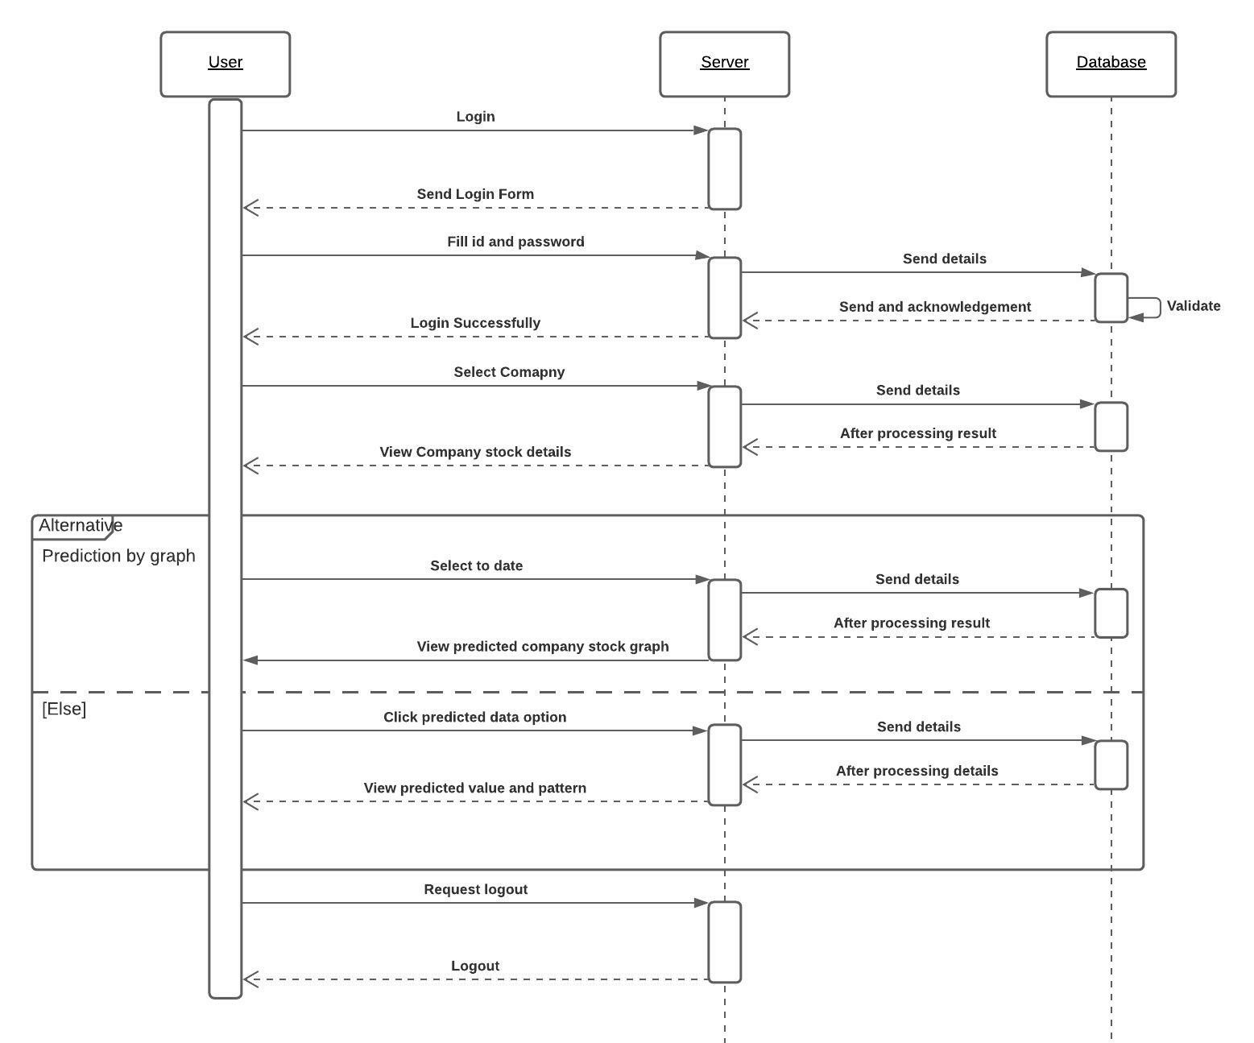

DFD

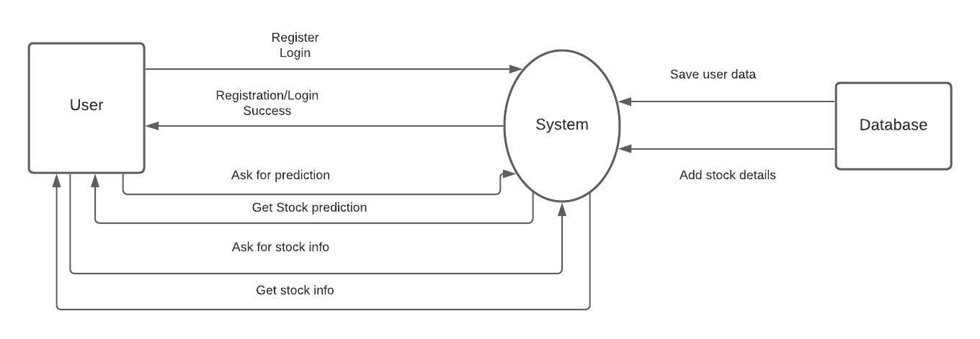

Architecture Diagram

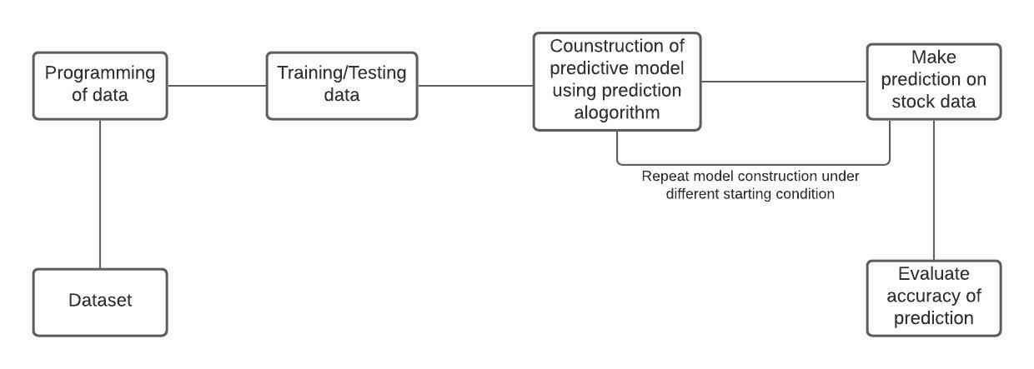

Class diagram

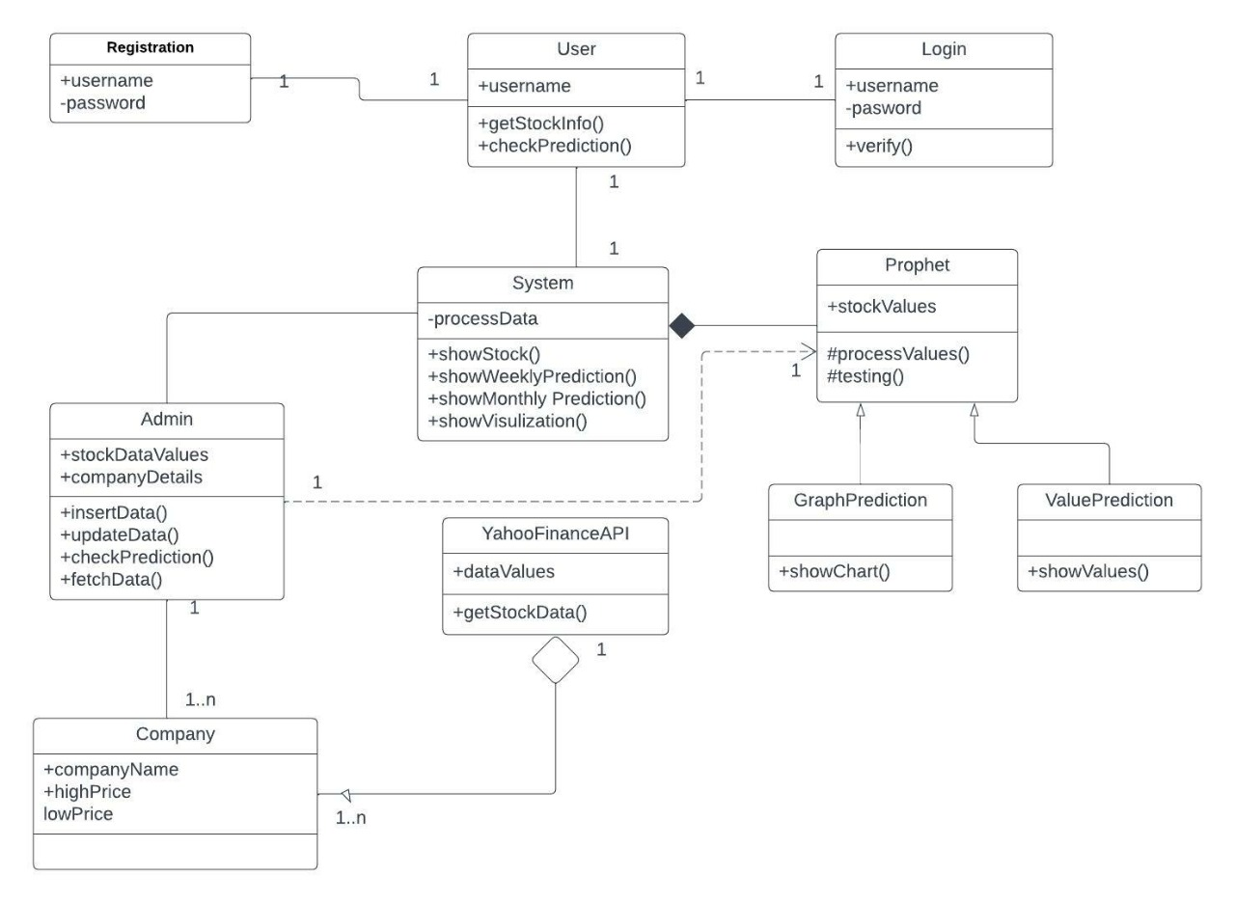

**PROJECT POSTER DETAILS**

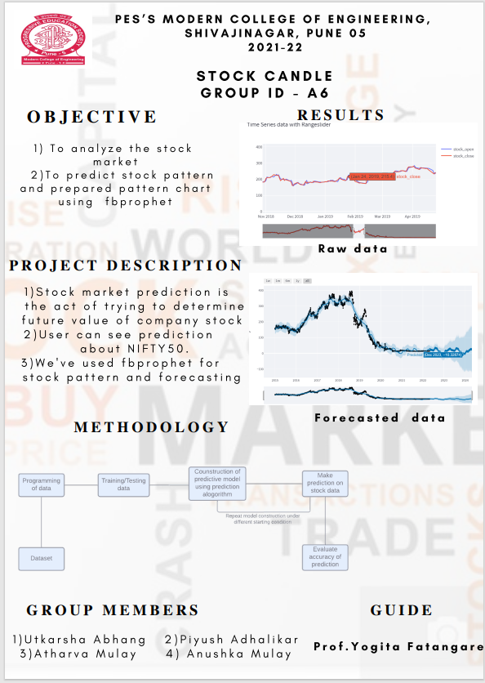

**PROJECT TOOL DETAILS**

**PROJECT TEST CASE EXECUTION DETAILS**

|  |  |  |  |  |  |
| --- | --- | --- | --- | --- | --- |
| Test case no | Test Case Name | Input | Expected Output | Actual Output | Result |
| 1 | Select a ticker symbol | User will search for ticker symbol of particular company | User should be able to search ticker symbol from the list |  | Pass |
| 2 | Select year | User will select year |  |  | Pass |
| 3 | Generate raw and forecast data in tabular format | User would able to see tail values of raw data and head values of forecasted data |  |  | Pass |
| 4 | Generate raw data with opening and closing price | User would see opening and closing price of every year |  |  | Pass |
| 5. | Generate forecast data in graphical format | User would see the forecasted data based on the selected year through slider |  |  | Pass |

**Semester – II**

**WEEKLY PLANNING SHEET**

**Academic Year:**

|  |  |  |  |  |
| --- | --- | --- | --- | --- |
| **Week No** | **Activities planned** | **Activity completed status** | **Student Signature** | **Guide Signature** |
|  | Project planning and requirement gathering | **Yes** |  |  |
|  | Learning Streamlit and flask Framework | **Yes** |  |
|  | Study of fb’s prophet algorithm | **Yes** |  |
|  | Updating UML diagrams | **Yes** |  |
|  | Preparing project report | **Yes** |  |  |
|  | Designing front end –login/registration | **Yes** |  |
|  | Creating firebase database | **Yes** |  |
|  | Authenticating firebase DB | **Yes** |  |
|  | connecting DB to forms | **Yes** |  |  |
|  | Adding ticker symbols | **Yes** |  |
|  | Creating prediction model | **Yes** |  |
|  | Connecting model to front end | **Yes** |  |

Project Coordinator Internal Guide

**PROJECT REVIEW – III**

|  |  |  |  |  |  |
| --- | --- | --- | --- | --- | --- |
| Group ID: | | A6 | | | Date: |
| Project Title: Stock Candle | | | | | |
| **Sr No.** | **Roll No** | | **Student Name** | **Contact Details** | Internal Guide Name:  Prof. Yogita Fatangare  Mentor Name, E-mail & Mobile No: 9923679494 |
| 1 | 45001 | | Utkarsha Abhang | 9822411446 |
| 2 | 45002 | | Piyush Adhalikar | 9730046037 |
| 3 | 45051 | | Atharva Mulay | 8275272640 |
| 4 | 45050 | | Anushka Mulay | 8275273140 |

**Review – III Implementation 25 Marks**

|  |  |  |
| --- | --- | --- |
| **Implementation (Source Code Review Checklist)** | | |
|  | **a. Structure** |  |
| 1. | Does the code completely and correctly implement the design? | Y / N / NA / NC* |
| 2. | Does the code comply with the Coding Standards? | Y / N / NA / NC* |
| 3. | Is the code well-structured, consistent in style, and consistently formatted? | Y / N / NA / NC* |
| 4. | Does the implementation match the design? | Y / N / NA / NC* |
| 5. | Are all functions in the design coded? | Y / N / NA / NC* |
|  | **b. Documentation** |  |
| 1. | Is the code clearly and adequately documented with an easy-to-maintain commenting style? | Y / N / NA / NC* |
| 2. | Are all comments consistent with the code? | Y / N / NA / NC* |

**STUDENT PERFORMANCE EVALUATION**

|  |  |  |  |  |  |  |
| --- | --- | --- | --- | --- | --- | --- |
| **Students’ Contribution and Performance** | | | | | **Marks (25M)** | |
| **Particulars** | | **Group Members** | | | | |
|  |  | 1 | 2 | 3 | | 4 |
| 1 | Architecture / System Design - (if any modification) |  |  |  | |  |
| 2 | Summarize the methodologies / Algorithms  implemented / to be implemented |  |  |  | |  |
| 3 | Partial Results obtained and Summarize the final findings of the Project |  |  |  | |  |
|  |  |  | |  |
| 4 | 70 % Implementation |  |  |  | |  |
| 5 | Contribution of the student |  |  |  | |  |
| 6 | Question and Answer |  |  |  | |  |
| 7 | Presentation skills |  |  |  | |  |
|  | Total (25) |  |  |  | |  |
|  | Comments (If any) | | | | | |

# To be filled by internal guide & reviewer(s) only.

* Whether the presentation / evaluation is as per the schedule. : YES / NO (If NO mention the reasons for the same.)

**Review – III: Deliverables**

* Detailed Design (if any deviation)
* 50% of code implementation
* Some Experimental Results
* Project Plan 3.0

Name & Signature of evaluation committee -

Name of Reviewer 1 Name of Reviewer 2 Name of Internal Guide

**PROJECT REVIEW – IV**

|  |  |  |  |  |  |
| --- | --- | --- | --- | --- | --- |
| Group ID: | | A6 | | | Date: |
| Project Title: Stock Candle | | | | | |
| **Sr No.** | **Roll No** | | **Student Name** | **Contact Details** | Internal Guide Name:  Prof. Yogita Fatangare  Mentor Name, E-mail & Mobile No: 9923679494 |
| 1 | 45001 | | Utkarsha Abhang | 9822411446 |
| 2 | 45002 | | Piyush Adhalikar | 9730046037 |
| 3 | 45051 | | Atharva Mulay | 8275272640 |
| 4 | 45050 | | Anushka Mulay | 8275273140 |

**Review – IV Testing 25 Marks**

|  |  |  |
| --- | --- | --- |
| **Testing** | | |
| 1. | Code implementation Status. |  |
| 2. | Result Analyses and Conclusion |  |
| 3. | Is Every Features to be Tested? |  |
| 4. | Are all functions, user screens, and navigation to be tested? (e.g. Module, Object, integration, usability, system)? |  |
| 5. | Test Cases (Manual and Automated) |  |
| 6. | Testing Tools Used |  |
| 7. | Overall Completion Status |  |
| 8. | Final Thesis Status |  |

**FILL IN BRIEF**

* Expected results are known or not? :
* Completion of Code status (%) :
* Quality of Presentation :
* Partial / Project Report Status :

(List the chapters completed as per format given)

* Project Completion Date :
* Partial / Final Report Submission Date :
* General
* Is the LOG BOOK of project up-to-date and signed?
* NC – Not Clear
* NA – Not Applicable

**STUDENT PERFORMANCE EVALUATION**

|  |  |  |  |  |  |  |
| --- | --- | --- | --- | --- | --- | --- |
| **Students’ Contribution and Performance** | | | | | **Marks (25M)** | |
| **Particulars** | | **Group Members** | | | | |
|  |  | 1 | 2 | 3 | | 4 |
| 1. | Summarize the methodologies / Algorithms |  |  |  | |  |
| 2. | implemented |  |  |  | |  |
| 3. | Results obtained and Performance Evaluation |  |  |  | |  |
| 4. | Summarize the ultimate findings of the Project |  |  |  | |  |
| 5. | Implementation (100%) |  |  |  | |  |
| 6. | Testing (Manual / Automated) |  |  |  | |  |
| 7. | Final Project Report |  |  |  | |  |
| 8. | Publications |  |  |  | |  |
| 9. | Contribution of the Student |  |  |  | |  |
| 10. | Question and Answer |  |  |  | |  |
|  | Total (25) |  |  |  | |  |
|  | Comments (If any) | | | | | |

# To be filled by internal guide & reviewer(s) only.

* Whether the presentation / evaluation is as per the schedule. : YES / NO (If NO mention the reasons for the same.)

**Review – IV: Deliverables**

* Detailed Design
* 100% of code implementation
* Experimental Results
* Performance Evaluation
* Test Cases
* Result Analyses and Conclusion
* Final Thesis
* Project Plan 4.0

Name & Signature of evaluation committee -

Name of Reviewer 1 Name of Reviewer 2 Name of Internal Guide

**PARTIAL / FINAL REPORT CONTENTS**

**Abstract (Report Abstract)**

An abstract is a brief summary or condensed version of the entire project, usually between 100 and 250 words long and written in the past tense. It includes the key points of the introduction, methods, results and conclusions of your project. The abstract takes the form of a paragraph, usually with 5-10 sentences. It should not include citations; use the background and conclusions to help to frame the context of your topic. Include keywords (the words that will help readers to search your report from repository or online) after abstract.

**Introduction**

Introduction should help to understand three key questions to the reader: Why is this important problem? What has been done before? How does your topic (problem) bring significant new understanding to the respective field? It should be written in present tense and should include the following points:

1. Outline the problem you are working on, why is it interesting, important and what are the challenges?
2. List your aims and goals. An aim is something you intend to achieve(e.g., learn a new programming language and apply it in solving the problem), while a goal is something specific you expect to deliver(e.g., a working application with a particular set of features)
3. Give an overview of how you have carried out the project (i.e. software development model)
4. A brief overview of the rest of the chapters in the report (a guide to the reader of the overall structure of the report).
5. This chapter is relatively short (2-4 pages) and must give the reader very clear understanding of what the project is about and what your goals are

**Background and Literature review**

This chapter should cover background information, related work, research done and tools or software used in the project.

1. Provide necessary framework and background information to describe how your project relates to what is already known or available.
2. A survey of existing solutions, programs or applications similar to your project (if necessary), and how your project is different than existing one
3. A description of the project work carried out to learn about methodology used for investigation of the problem.
4. The form of the project work will vary widely depending on the kind of project. Outline and key sources of information you are using (papers, books, websites, etc.). State how each source is related to your work.
5. Introduce the software, programming languages, library code, frame-works and other tools that you have used. Discuss choices and make clear which you made use of and why.

**Requirements and Analysis**

1. Give the detailed problem statement. This elaborates on what you may have included in the introduction chapter and represents the starting point from which requirements were derived. **Problem Definition:** Define/formulate the problem clearly and concisely of your projectwork. Provide details of the overall problem and then divide the problem into module(s).
2. **Requirements Specification:** A structured list of requirements. The requirement specificationsdetermine specific feature expectations, resolution of conflict or ambiguity in requirements as demanded by the various users or groups of users and documentation of all aspects of the project development process from start to finish. Here you should define the requirements of the system, independent of how these requirements will be accomplished and identify the operation and problems of the existing system.
3. Description of Use cases/documentation (list of use case titles, with the full use cases appearing in the appendix).
4. **Software and Hardware Requirements:** Define the details of all the software and hardwareneeded for the development and implementation of your project.

**Design**

1. Start with the architecture of your project and describe all components that make up the system.
2. You can use necessary DFDs and UML diagrams with proper explanation of your project design.
3. The structure and contents of this chapter will vary according to the nature of your project, hence above mentioned list of requirements is only representative.

**Implementation**

This chapter is about the realization of the concepts and ideas developed earlier. You can describe the methodology (problem formulation and processes used to solve the problem) you have identified for the development of your system/application (Literature review will help you to identify/choose methodology). It can also describe any problems that may have arisen during implementation and how you dealt with them. It should include the details regarding all modules of the project and description of each module. It may be better to use pseudo-code rather than actual code, when describing an algorithm. Describe how a particular algorithm is implemented or how an interesting programming problem was solved.

**Results and Evaluation**

In this chapter, you should describe to what extent you achieved your goals and how the system works as intended (or not, as the case may be). Include comprehensible summaries of the results of all critical tests that were carried out.

1. Describe experimental setup.
2. Describe your testing strategy (unit, functional, acceptance testing and how they are carried out). How were test cases selected?
3. Examples of specific tests and how they were carried out (e.g., using mock objects to break dependencies).Focus on the interesting test cases.
4. A summary of the test results and what coverage was achieved. The detailed test report(s) should appear in the appendix.

**Conclusion**

Demonstrate that you solved the problem or made significant improvement in the existing system/application. You can use illustrations such as tables, figures, graphs etc to support the conclusions.

1. Summarize what your project has achieved. Address each objective decided in the introduction.
2. A critical evaluation of the results of the project (e.g., how well were the objectives met, is the application fit for purpose, has good design and implementation practice been followed, was the right implementation technology chosen and so on).
3. Results should be clear and concise.
4. State why your solution offers a new/improved solution
5. Acknowledge any limitations

**References**

1. List of references.
2. Bibliography: This lists all the sources of information that you made use of during the project but are not referenced in the text. The items in the list must be relevant to your project, so don't just list everything you may have looked at or read.

**PROJECT REPORT FORMAT**

**Instructions:**

It is important that the procedures listed below be carefully followed.

1. Prepare 2 + No. of project members’ copies of your manuscript (1-CD for college).
2. Limit your project report to preferably 60-70 manuscript pages.
3. The footer should be included as “College Name - INFORMATION TECHNOLOGY – <<Academic Year>>” while the header should contain” NAME OF PROJECT”. Both header and footer should be TIMES NEW ROMAN 10pt and centrally aligned.
4. Print the manuscript using letter quality computer printing. The main part of manuscript should be TIMES ROMAN 12pt and justified. Use 1.5 line spacing and justify aligned
5. Use paper size 8.5” X 11” or A-4(210X197mm). Please follow following margins

|  |  |
| --- | --- |
| Margin Location | Paper A4 (210X197mm) |
| Top | 25.4 mm |
| Left | 37 mm |
| Bottom | 32 mm |
| Right | 25.4 mm |

1. All paragraphs will be 1.5 line spaced and a double space between each paragraph. Each paragraph will begin with a five–space indentation.
2. Chapter titles should be bold with 14pt typed in all capital letters and should be aligned at the center of the page. Section heading should be aligned at the left with 12pt and bold and capitalized. Section subheading should be aligned at the left with title case (the first letter of each word is to be capitalized). Leave two spaces between section headings and 1 space between two section subheadings.
3. Illustrations (Charts, drawings photographs, figures) are to be in the text. Use only illustrations really pertinent to the text. Illustrations must be sharp, clear, black and white. Illustrations downloaded from internet are not acceptable.
   1. Illustrations should not be more than two per page. One could be ideal
   2. Figure No. and title at bottom with 12pt.
   3. Legends below the title in 10pt.
   4. Proper margin in all sides.
   5. Illustrations as far as possible should not be Xeroxed (photo copy)
4. Photographs if any should be of glossy prints.
5. Please use SI system for units. If student would like to add the equivalent in inch-pound (IP) units, they must be stated in parentheses after the SI units. In case the final result comes out in any other units (say due to empirical formula etc.) convert the unit to SI unit.
6. Please number the pages on the front side, centrally below the footer.
7. References should be either in order as they appear in the paper or in alphabetical order by last name of first author.
8. Symbols and notations if any should be included in nomenclature section only.
9. Following will be the order of the report.
   1. Cover page and front page as per specimen on separate sheet.
   2. Certificate from institute as per specimen on separate sheet.
   3. Certificate from industry on separate sheet (as case may be).
   4. Acknowledgement.
   5. List of figures.
   6. List of Tables
   7. Nomenclature
   8. Contents
   9. Abstract (A brief abstract of the report not more than 150 words. The heading of abstract i.e. word

“Abstract” should be bold, times roman 12 pt and should be typed at the center. The contents of abstract should be typed on new line without space between heading and contents.

* 1. Chapter1 : Introduction
  2. Other chapters starting on new page.
  3. References (In IEEE format)
  4. Appendices if any. Appendix should contain routine calculation, standard data, derivation and relevant cyber laws.

1. All chapters, section heading and subheadings should be numbered. For chapters use numbers 1, 2……. And for subheadings 1.1, 1.2 etc. and section subheadings 2.1.1, 2.2.2, 2.3.1 etc.
2. References should be given in the body of the text and well spread. No verbatim copy or excessive text from only one or two reference should be used. If figures and tables are taken from any reference then indicate its source. Please follow following procedure for references.

**Reference books**

Collier. G. j. and Thome J. R., Convective boiling and condensation, 3rded, Oxford University Press, UK. 1996, pp. 110-112

**Papers from Journal or transactions**

JUNG D. S. and Raderamcher R. “Transport properties and surface tension of pure and mixed refrigerants”, Ashare

Trans, 1991, 97(1), p. 90-98

**Papers from conference proceedings**

Colboumne D. R and Ritter T. J. “Quantitative assessment of flammable refrigerants in room air conditioners”, proceedings of the sixteenth International compressor Engineering Conference and Ninth International Refrigeration and Air conditioning Conference, Putdu University, West Lafayette Indiana, USA, 2002

**Reports Handbooks etc.**

United Nations Environmental Programme, Report of the refrigeration, Air Conditioning and heat pumps, Technical option Committee, 2002 Assessment,2002

ASHRAE handbook : Refrigeration, 1994 (chapter44)

**Patent**

Patent no. Country (In parenthesis), date of application, title, year. If taken from “Abstract” give cross reference as CF, CA…….

**Internet**

WWW.(Site)

**COMMUNICATION BETWEEN INTERNAL GUIDE AND MENTOR OF SPONSORED COMPANY**

|  |  |  |
| --- | --- | --- |
| **Sr. No** | **Date** | **Summary of Discussion** |
|  |  |  |
|  |  |  |
|  |  |  |

**OBSERVATIONS BY EXTERNAL EXAMINERS**

|  |  |  |
| --- | --- | --- |
| **Exam** | **Date** | **Observations** |
| Phase – I |  |  |
| Phase - II |  |  |
| Other |  |  |

**CO-CURRICULAR ACTIVITY RECORD**

(Paper presentation, Conference, Competition, Industrial Visit)

**(Attach Xerox copy of certificate/s)**

|  |  |  |  |
| --- | --- | --- | --- |
| **Sr. No** | **Activity Details** | **Date** | **Prizes(if any)** |
|  |  |  |  |
|  |  |  |  |
|  |  |  |  |
|  |  |  |  |
|  |  |  |  |
|  |  |  |  |
|  |  |  |  |

**PASTE YOUR SPONSORSHIP LETTER**

(Offer Letter and completion letter)

**PASTE YOUR INTERNSHIP LETTER**

(if applicable)

**PASTE YOUR PUBLISHED PAPER**

**PASTE YOUR PROJECT RELATED CERTIFICATES**

(Poster, Project competition, publication, copyright, patent etc.)